

Problem Statement:

“IOT BASED SMART IRRIGATION SYSTEM”.

B.E in Mechanical Engineering

Class: 4TH Sem ‘B’ div

2022-23

Mechatronics

Project By:

|  |  |  |  |  |
| --- | --- | --- | --- | --- |
| Sl. No | Name | Roll No | SRN | Signature |
| 1 | VASUDEV. N. | 203 | 01FE20BME125 |  |
| 2 | ROHIT. V | 205 | 01FE20BME133 |  |
| 3 | ADITYA. D | 2 | 01FE20BME138 |  |
| 4 | SOURABH. P | 211 | 01FE20BME135 |  |
| 5 | NANDISH. A | 218 | 01FE20BME076 |  |



*ABSTRACT:*

Automation of farm activities can transform agricultural domain from being manual and static to intelligent and dynamic leading to higher production with lesser human supervision. This paper proposes an automated irrigation system which monitors and maintains the desired soil moisture content via automatic watering. Microcontroller ATMEGA328P on Arduino uno platform is used to implement the control unit. The setup uses soil moisture sensors which measure the exact moisture level in soil. This value enables the system to use appropriate quantity of water which avoids over/under irrigation. IOT is used to keep the farmers updated about the status of sprinklers. Information from the sensors is regularly updated on a webpage using GSM-GPRS SIM900A modem through which a farmer can check whether the water sprinklers are ON/OFF at any given time. Also, the sensor readings are transmitted to a Thing speak channel to generate graphs for analysis.

1. INTRODUCTION:

Agriculture is the unquestionably the largest livelihood provider in India. With rising population, there is a need for increased agricultural production. In order to support greater production in farms, the requirement of the amount of fresh water used in irrigation also rises. Currently, agriculture accounts 83% of the total water consumption in India [1]. Unplanned use of water inadvertently results in wastage of water. This suggests that there is an urgent need to develop systems that prevent water wastage without imposing pressure on farmers. Over the past 15 years, farmers started using computers and software systems to organize their financial data and keep track of their transactions with third parties and also monitor their crops more effectively [2]. In the Internet era, where information plays a key role in people's lives, agriculture is rapidly becoming a very data intensive industry where farmers need to collect and evaluate a huge amount of information from a diverse number of devices (e.g., sensors, faming machinery etc.) in order to become more efficient in production and communicating appropriate information [3]. With the advent of open-source Arduino boards along with cheap moisture sensors, it is viable to create devices that can monitor the soil moisture content and accordingly irrigating the fields or the landscape as an when needed. The proposed system makes use of microcontroller ATMEGA328P on Arduino uno platform and IOT which enable farmers to remotely monitor the status of sprinklers installed on the farm by knowing the sensor values thereby, making the farmers' work much easier as they can concentrate on another farm activities.



**Project Statement**:

In this project, we will learn about the IoT Based **Smart Agriculture** & **Automatic Irrigation System** with **Nodemcu ESP8266**. Agriculture plays a vital role in the development of agricultural countries. Some issues concerning agriculture have been always hindering the development of the country. Consequently, the only solution to this problem is **smart agriculture** by modernizing the current traditional methods of agriculture. This would make irrigation smart and efficient by inclusion of technology.

**System Function**:

In IoT based smart agriculture, a system is formed to monitor the farmland with the help of sensors, which senses components like temperature, light, humidity, soil moisture, etc. Then, automate the irrigation system and allow farmers to monitor their field conditions from anywhere through IoT Analytics Platform. To make the agricultural process even smarter and accurate, precision agriculture is used. This makes agricultural practice more controlled and precise in terms of raising livestock and farming. IoT based Smart Farming plays a vital role when it comes to the use of IT and other elements like sensors, agricultural drones, autonomous vehicles, control systems, automated hardware, robotics, variable speed technology, and others.



*List Of Components used:*

|  |  |  |
| --- | --- | --- |
| Sl no. | DEVICE | PARTICULARS |
| 1. | Node MCU | ESP8266 |
| 2. | Single Channel Relay  Module | 5v |
| 3. | Mini Water Pump | 5v |
| 4. | Soil Moisture Sensor | **Capacitive Soil Moisture V1.2** |
| 5. | Humidity Sensor | DHT11 |
| 6. | Smart Phone |  |



OVERVIEW:



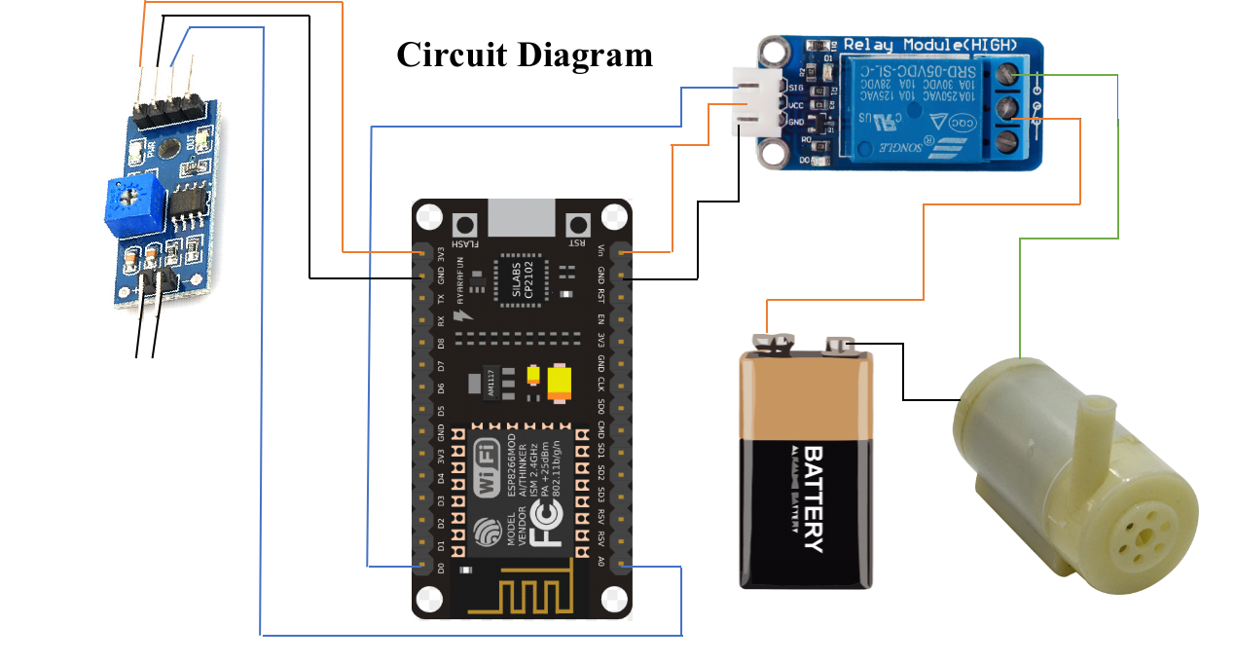



*Schematic Diagram of the Circuit:*



Simulated via Arduino Software

*Code:*

#define BLYNK_PRINT Serial    // Comment this out to disable prints and save space

#include <SPI.h>

#include <ESP8266WiFi.h>

#include <BlynkSimpleEsp8266.h>

#include <SimpleTimer.h>

#include <DHT.h>

// You should get Auth Token in the Blynk App.

// Go to the Project Settings (nut icon).

char auth[] = ""; //Enter the Auth code which was send by Blink

// Your WiFi credentials.

// Set password to "" for open networks.

char ssid[] = "airtel blackberry hotspot 3443";  //Enter your WIFI Name

char pass[] = "12345678";  //Enter your WIFI Password

#define DHTPIN 2          // Digital pin 4

// Uncomment whatever type you're using!

#define DHTTYPE DHT11     // DHT 11

//#define DHTTYPE DHT22   // DHT 22, AM2302, AM2321

//#define DHTTYPE DHT21   // DHT 21, AM2301

DHT dht(DHTPIN, DHTTYPE);

SimpleTimer timer;

// This function sends Arduino's up time every second to Virtual Pin (5).

// In the app, Widget's reading frequency should be set to PUSH. This means

// that you define how often to send data to Blynk App.

void sendSensor()

{

  float h = dht.readHumidity();

  float t = dht.readTemperature(); // or dht.readTemperature(true) for Fahrenheit

  if (isnan(h) || isnan(t)) {

    Serial.println("Failed to read from DHT sensor!");

    return;

  }

  // You can send any value at any time.

  // Please don't send more that 10 values per second.

  Blynk.virtualWrite(V5, h);  //V5 is for Humidity

  Blynk.virtualWrite(V6, t);  //V6 is for Temperature

}

void setup()

{

  Serial.begin(9600); // See the connection status in Serial Monitor

  Blynk.begin(auth, ssid, pass);

  dht.begin();

  // Setup a function to be called every second

  timer.setInterval(1000L, sendSensor);

}

void loop()

{

  Blynk.run(); // Initiates Blynk

  timer.run(); // Initiates SimpleTimer

}

